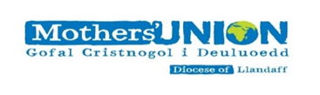
Would you like to hear more about our Mothers’ Union?
Come along to our first ever:

LLANDAFF DIOCESAN
GENERAL MEETING

to be held at
The Jury’s Hotel, Park Place, Cardiff
on
Tuesday 10 October 2017
at
10.00am for 10.30am start

ALL MEMBERS WELCOME

Tickets: £5 to include Coffee
Lunch Optional at a total cost of £20.00 (Please order beforehand)
Further details available from your Deanery/Branch Leader

